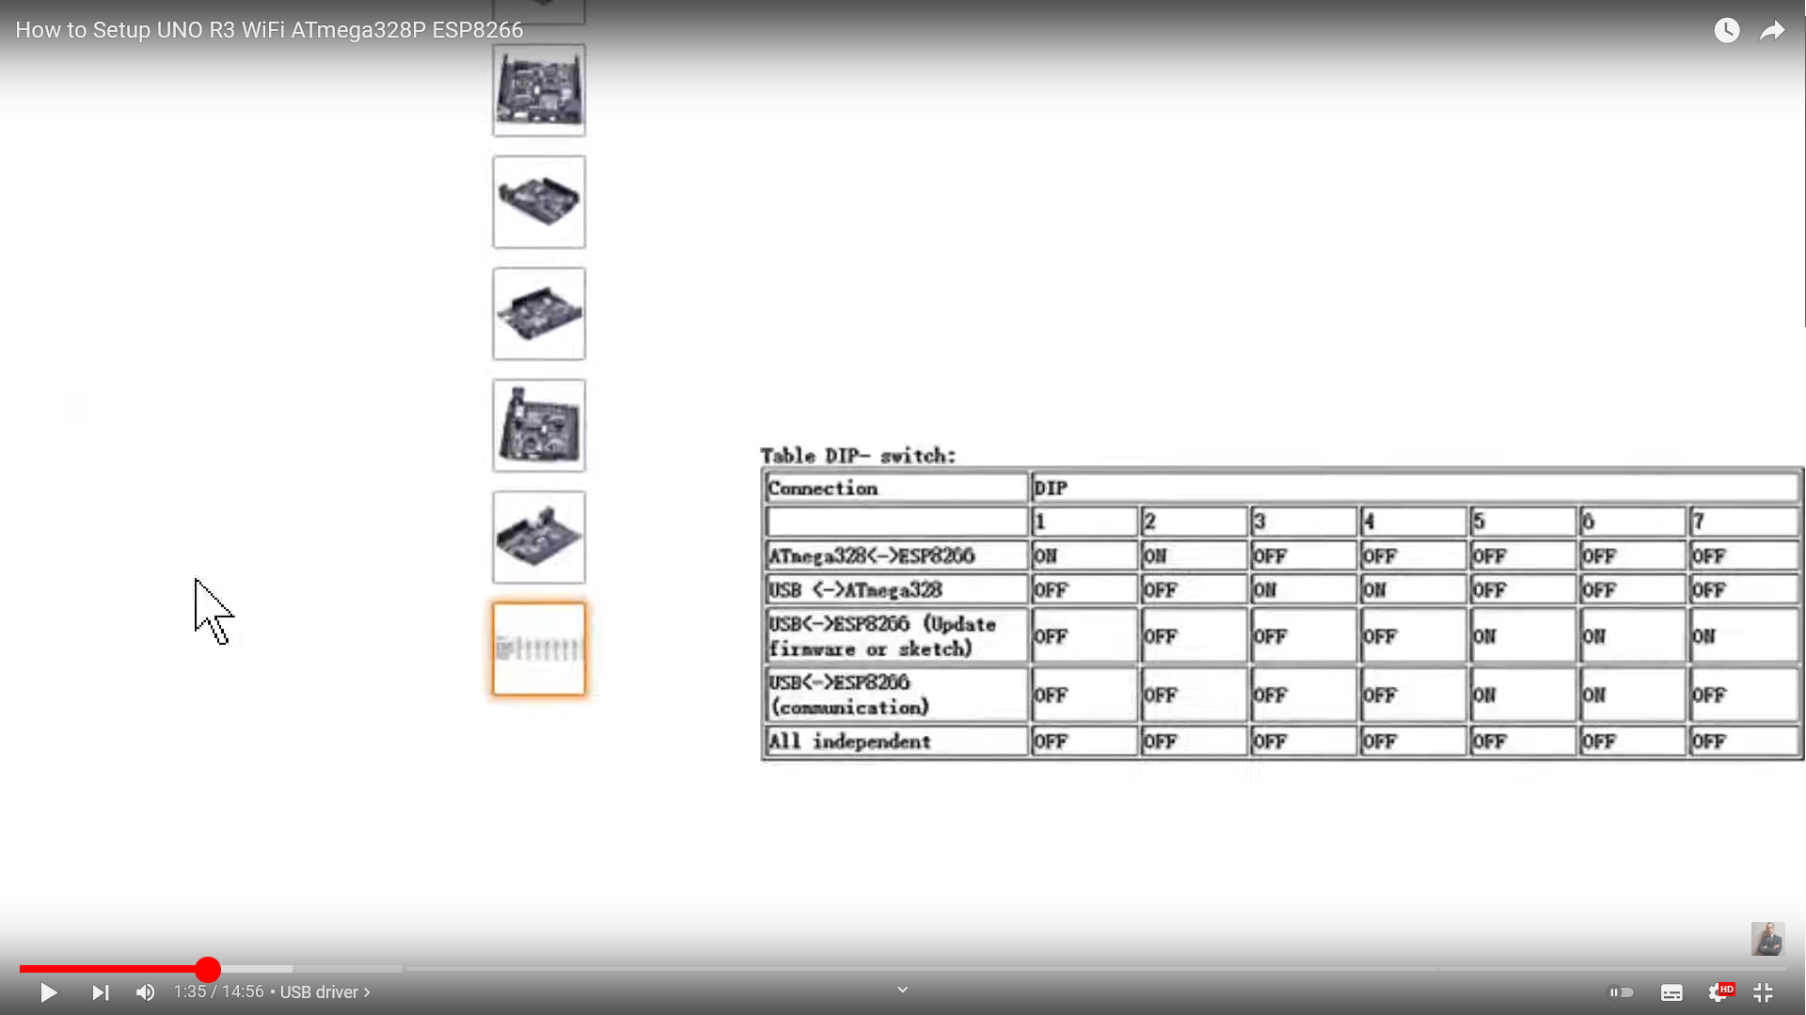

→ PIGIARE RESET PER PROGRAMMARE
+
UPLOAD 5,6,7
AFTER UPLOAD BEFORE DISCONNECT
5-6 otherwise reset

ESP-MEGA
//Dip switch 1,2 are set "On" to connect the ATmega and ESP serial TX/RX
// If you want to read the ESP in the serial monitor whilst ATmega and ESP connected then set dip switch 1,2,5,6 to "On"; at this setting any Serial.println will be sent back to the Atmega and confuse the JSON parsing so comment them all out that you do not want sent
MEGA
// Simple sketch on Arduino ATmega328 to send preset data in a "temp" JSON field to the ESP8266
// Upload to ATmega328 with dip switch 3,4 set ON
// To read the serial monitor for messages sent and returning message set dip switch 1,2,3,4 ON
// ArduinoJson must be version 5 https://arduinojson.org/v5/doc/ , in the future need to change code in

I am sending JSON objects to reed them by each others in TX and RX.
To communicate between Arduino and ESP you will need to activate deep switches 1 and 2.
To upload a sketch on ESP: 5, 6, 7.
To upload on Arduino: 3, 4.
Don’t forget to change board options before uploading when switching.
To see what is transferred to ESP from Arduino: 1, 2, 3, 4.
To see what is transferred to Arduino from ESP: 1, 2, 5, 6.
(by opening serial terminal)
this sketch for Ver 6

